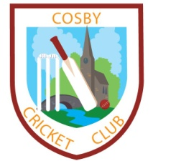 Cosby Cricket Club 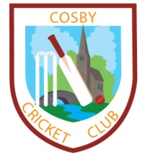
Victory Park, Park Road
Cosby, Leicestershire
Tel: 07968334042
e-mail n.meredith@hotmail.co.uk

COSBY CRICKET CLUB MEMBERSHIP FORM:

(Please answer all questions)

Name(s): __________________________ DOB: _______________
Surname: __________________________ (dd/mm/yy)
Postal Address: __________________________________________________________
__________________________________________________________
__________________________________________________________
Phone: ________________________ Mobile: _______________
Email Address: ____________________________
Medical Conditions_________________________
Type of Membership: (please tick)

Full Senior (£25.00)
Junior (Under 18s) – membership covers all junior nets and junior match fees (£40.00)
Method of Payment: (please tick)
Cash
Cheque (Pay to Cosby Cricket Club)

Signature: _____________________
(of parent if under 18)
Date: ___________________

For Office use only:

Paid Signature: _____________________
Date: _______________ (Club Secretary)

